Coquet Hydro Ltd R&D Potential
Retrospective Review of the Guyzance Hydroelectric Projects R&D Qualities

=-=-=-=-=-=-=-=-=-=-=-=-=-=-=-=-=-=-=-=-=-=-=-=-=-=-=-=-=-=-=-=-=-=-=-=-=-=-=-=-=

Projects that count as R&D must show [1]:
1 – How has the project looked for an advance in science and technology
2 – How has the project had to overcome uncertainty
3 – How has the project tried to overcome this uncertainty
4 – How has the project overcome this uncertainty which a professional in the field could not easily have worked out

This document will henceforth address each of these considerations separately. Attached within the appendices are a number of images providing an overview of the project being undertaken (See Appendix 1, Appendix 2 & Appendix 3).

Guyzance hydroelectric project (GHEP) is an example of a low-head (5 m drop between inlet and outlet) system based on the artificial cut-off through a sizeable meander (~1.75 km in length) on the river Coquet. It is technically an example of a “gravity” run system as it employs an Archimedes screw [2], whilst it relies upon the “diversion” mechanism for its delivery of water [3]. It must be made clear from the outset that this project does not intend to re-route the entire river through the cut-off, but instead to divert a small portion of the flow away from the main watercourse during periods of spate. It is unique in that it diverts this flow at 90° to the rivers course, hence avoiding obstruction of natural sediment passage downstream, a negative environmental impact caused by typical HEPs constructed axially to river flow. In addition to this, GHEP allows the Coquet to behave in a manner natural to spate rivers, as it presents no resistance to the flow and thus avoids increasing flood risks above or below the project.

To the best of our knowledge no small-scale projects ($≤$100 kW) based on such an endeavour have been developed in the UK. This may be due to advice such as is presented in guides to hydroelectric scheme siting, e.g. in the IFC’s guide of 2015, it is stated that “Typically, river bends or meanders should be avoided because the inner sides of the bends accumulate sediment and the outer side is subject to erosion and flood damage” [4].

Although it is made clear in this short R&D review that the GHEP is an entirely novel venture, it is important to point out that the surrounding Guyzance microgrid infrastructure (GMI) to be developed is also a unique development. As opposed to the majority of HEPs, GHEP is not built with the intention of taking advantage of the feed-in tariff system, it is instead expected to develop a sustainable supply of energy to the local estate. This research into microgrid infrastructure hopes to not only yield a sustainable source of energy, but also to provide a higher quality of power (three phase AC), where the national infrastructure has failed to modernise to such a standard as of yet.
=-=-=-=-=-=-=-=-=-=-=-=-=-=-=-=-=-=-=-=-=-=-=-=-=-=-=-=-=-=-=-=-=-=-=-=-=-=-=-=-=

1 – Advance in the field
Aim to create an advance in the overall field, not just your business.
By proving that low-head hydroelectric generation (using an Archimedes screw) on a meander cut-off is technically feasible and provides clear aquatic-ecological benefits, a precedent has been set for further development of the hydroelectric resource nationally within this niche geographical feature.

Can’t just be an existing technology that has been used for the first time in your sector.
Although Archimedes screw systems have been deployed in low-head hydroelectric formats across the UK, the vast majority capitalise off of the artificial infrastructure facilitating their elevation head (e.g weirs). Coquet Hydro is pioneering a low-head hydroelectric system which obtains a natural elevation head by making use of a meander cut-off. Resultantly, this provides both a sustainable technical working principle, as well as an ecologically suitable system fit for the migratory routes of salmonids in its waters.

2 – Show there was uncertainty
A scientific or technological uncertainty exists when an expert on the subject cannot say if something is technologically possible or how it can be done – even after referring to all available evidence.
Uncertainty lies in the potential aquatic-ecological benefits possessed by the meander cut-off low-head hydroelectric scheme. Hence the equivalent hypothesis to be tested by this R&D project is “Low-head meander cross-cut hydroelectric systems have lower impact on fish migration than weir-based alternatives”.

This means that your company or experts in the field cannot already know about the advance or the way you could achieve it.
Due to the novelty of the project, neither Coquet Hydro Ltd nor any experts in the field know the exact impact on fish migration a meander cut-off hydroelectric system will have. Only educated guesses as to possible influences may be deduced by cross-examination of tributaries effects on migration along watercourses.

3 – Explain how you tried to overcome the uncertainty
You should show that the R&D needed research, testing and analysis to develop it.
To overcome this uncertainty the Guyzance Hydroelectric project was developed on the river Coquet by Coquet Hydro Ltd. This provided both a hydroelectric plant for the production of renewable power, as well as a testbed for research into the aforementioned hypothesis. This infrastructure facilitated testing of salmon presence in the outlet basin, thus indicating the abatement time caused by the flow perturbation.

You need to be able to explain the work you did to overcome the uncertainty. This can be a simple description of the successes and failures you had during the project.
Dependent upon project being undertaken.

4 – Show that a professional in the field could not work this out
You should explain why a professional could not easily work out your advance
A professional could not easily have worked out the effects of such a project, as the dynamics of the riverbed cannot be anticipated in advance. A physical study is necessary to allow deduction of effects of such systems.

You can do this by showing that other attempts to find a solution failed

You can also show that the people working on your project are professionals in that field and get them to explain the uncertainties involved

=-=-=-=-=-=-=-=-=-=-=-=-=-=-=-=-=-=-=-=-=-=-=-=-=-=-=-=-=-=-=-=-=-=-=-=-=-=-=-=-=

Appendix

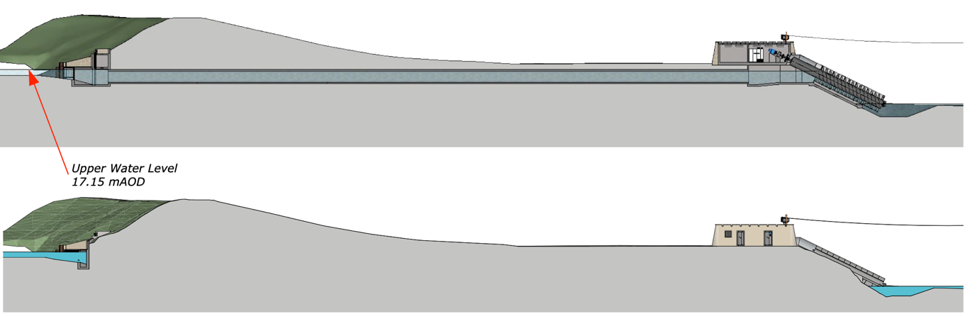
Appendix 1 – Cross-sectional view of meander cut-off hydroelectric scheme.
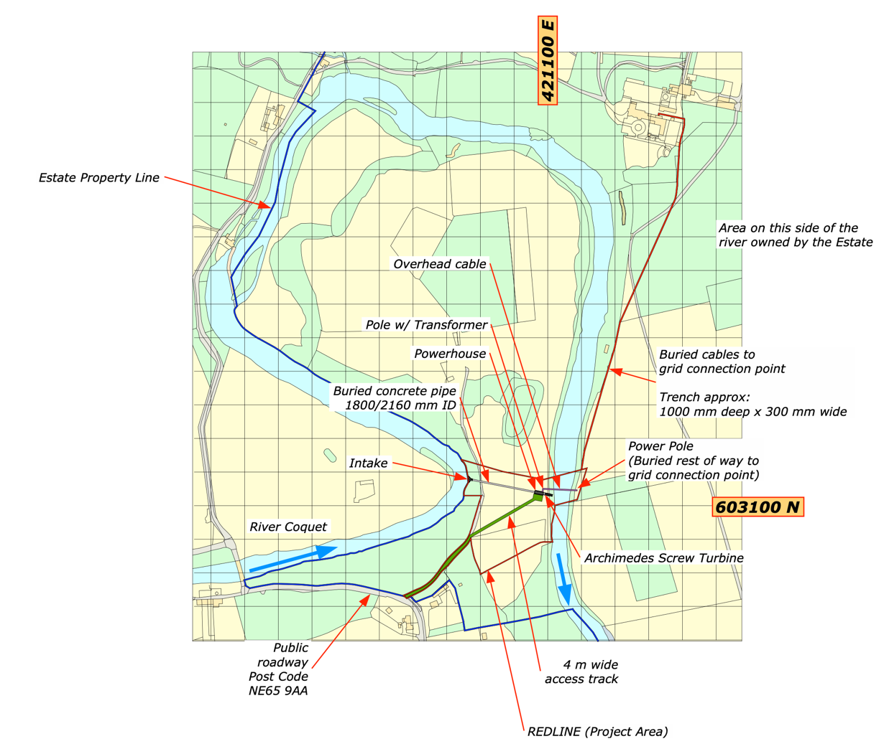
Appendix 2 – Overview of red-line boundary of project and surrounding meander.

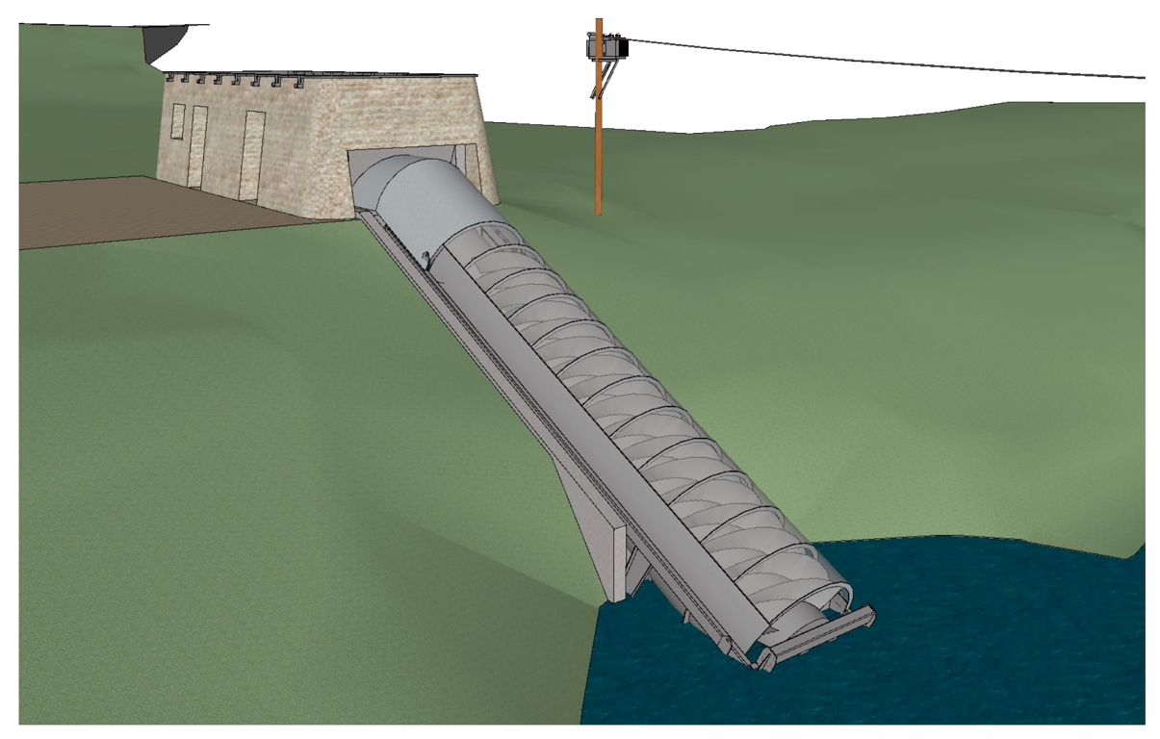
Appendix 3 – Simple render of potential outlet point and associated turbine house.

Bibliography

[1] GOV.UK. "Claiming Research and Development tax reliefs." HMRC. https://www.gov.uk/guidance/corporation-tax-research-and-development-rd-relief (accessed 30th Nov, 2020).
[2] BHA. "A guide to UK mini-hydro developments." British Hydropower Association. http://www.british-hydro.org/wp-content/uploads/2018/03/A-Guide-to-UK-mini-hydro-development-v3.pdf (accessed 30th Nov, 2020).
[3] WPTO. "Types of Hydropower Plants." USDOE. https://www.energy.gov/eere/water/types-hydropower-plants (accessed 30th Nov, 2020).
[4] IFC, International Finance Corporation, Germany, 2015. [Online]. Available: https://www.ifc.org/wps/wcm/connect/topics_ext_content/ifc_external_corporate_site/sustainability-at-ifc/publications/hydroelectric_power_a_guide_for_developers_and_investors

